SIMATS ENGINEERING
ASSESSMENT TOOL 2

COURSE CODE: ITA 0606 COURSE NAME: MACHINE LEARNING

COURSE OUTCOME COVERED

CO1: Learning Problems, Perspectives and Issues, Concept Learning, Version Spaces & Candidate Elimination, Inductive Bias, Decision Tree Learning, Representation & Heuristic Search (BL1, BL2)

Assessment Tool Weightage: 20%

QUESTIONS: 15 Total Marks: 25

Annexure A

CONCEPT MAPPING

Code of Conduct:

I k preetham chowdary certify that this submission is my original work and that I have adhered to the guidelines specified for this assessment.
I understand that any violation of academic integrity rules will result in disciplinary action.

Signature of the student:

K preetham chowdary

1. With the necessary sketch, explain all the possible blocks in the machine-learning system. Give example for showing the concept of the supervised and Un-supervised learning methods in the machine learning scheme.

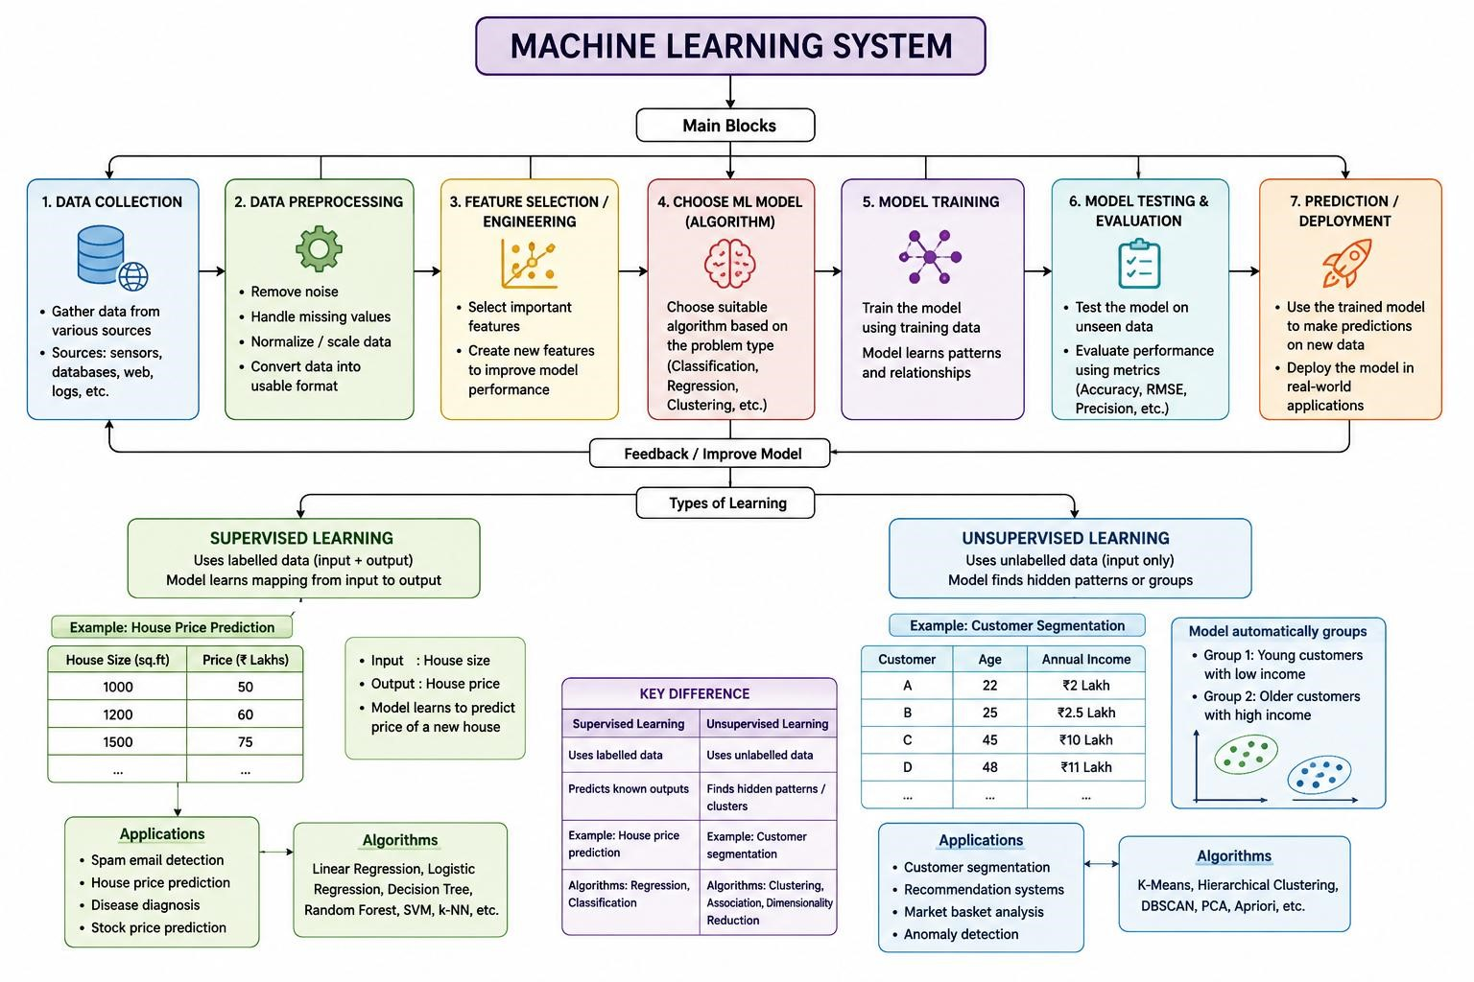

Design a machine learning system for disaster management to predict events such as floods and earthquakes using historical and real-time data. Explain the choice of model, data preprocessing, and feature selection techniques.
(a) Describe the steps involved in training, validating, and evaluating the model. (b) Explain how the system can assist in early warning and emergency response.

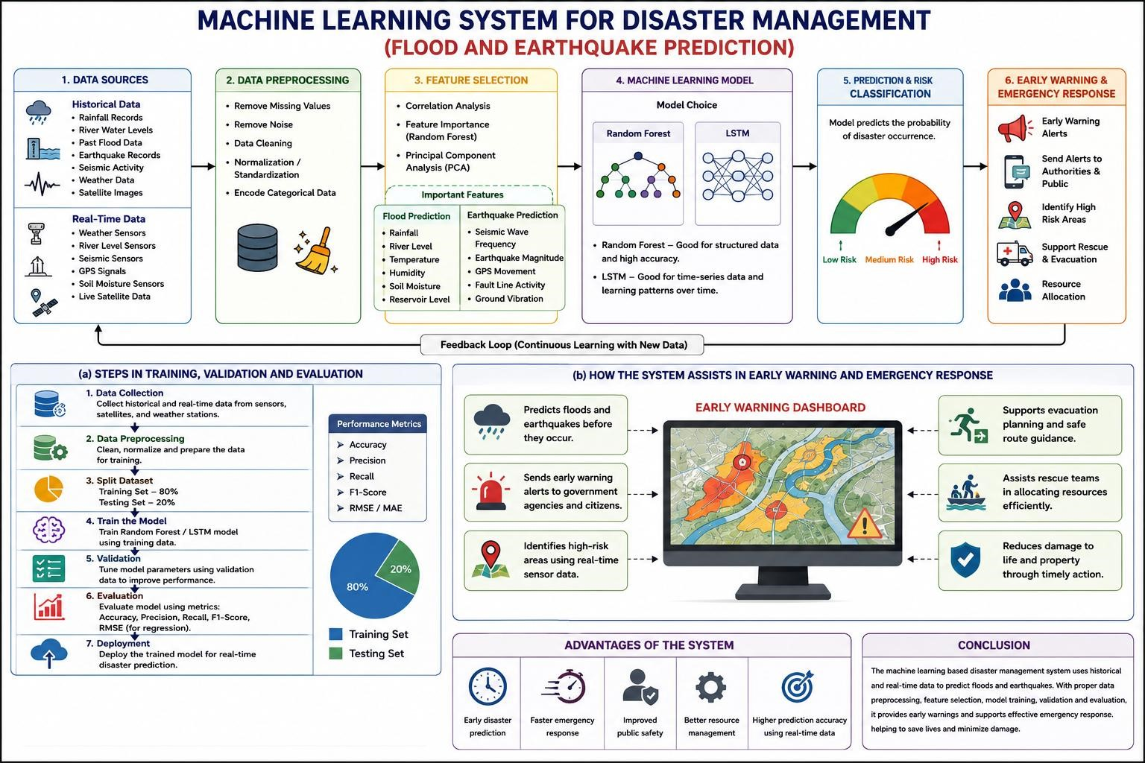

In the context of Find-S algorithm, consider the following dataset used to determine whether a day is suitable for playing tennis based on attributes such as Outlook, Temperature, Humidity, and Wind. Apply the Find-S algorithm to determine the maximally specific hypothesis. Show the step-by-step updates of the hypothesis after
each positive training example and ignore all negative examples. Finally, provide the
final hypothesis. (5 Marks)

Dataset:
Example | Outlook | Temperature | Humidity | Wind | Play Tennis
1 | Sunny | Hot | High | Weak | No
2 | Sunny | Hot | High | Strong | No
3 | Overcast | Hot | High | Weak | Yes
4 | Rainy | Mild | High | Weak | Yes
5 | Rainy | Cool | Normal | Weak | Yes
6 | Rainy | Cool | Normal | Strong | No
7 | Overcast | Mild | Normal | Strong | Yes
8 | Sunny | Mild | High | Weak | No

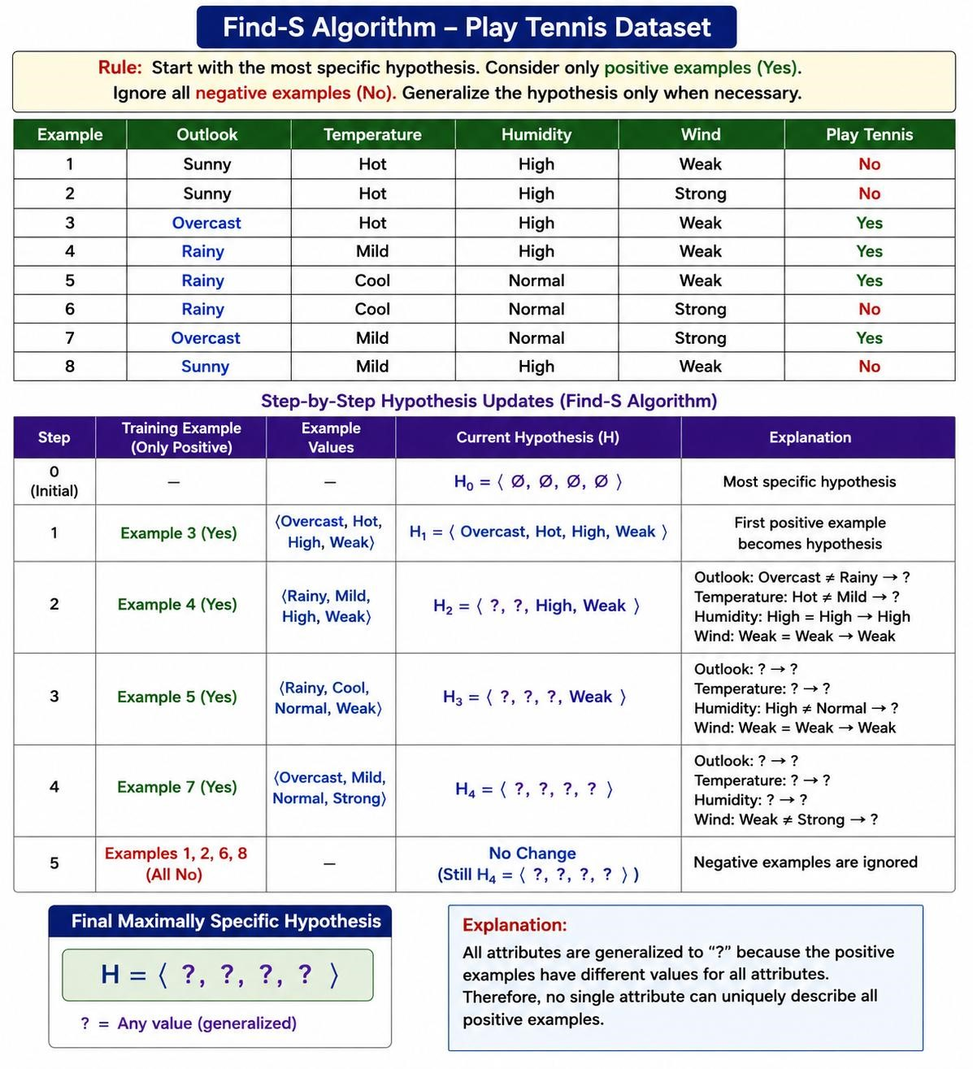

In the context of the Candidate Elimination algorithm, consider a dataset used to classify whether a person will enjoy a sport based on attributes such as Weather, Temperature, Humidity, and Wind. Using the Candidate Elimination algorithm, determine the version space by computing both the specific (S) and general (G) boundaries. Show the step-by-step updates after processing each training example.
(5 Marks)

Dataset:
Example | Weather | Temperature | Humidity | Wind | Enjoy Sport
1 | Sunny | Warm | Normal | Weak | Yes
2 | Sunny | Warm | High | Strong | Yes
3 | Rainy | Cold | High | Weak | No
4 | Sunny | Cold | Normal | Weak | Yes
5 | Warm Rainy |  | Normal | Strong | No
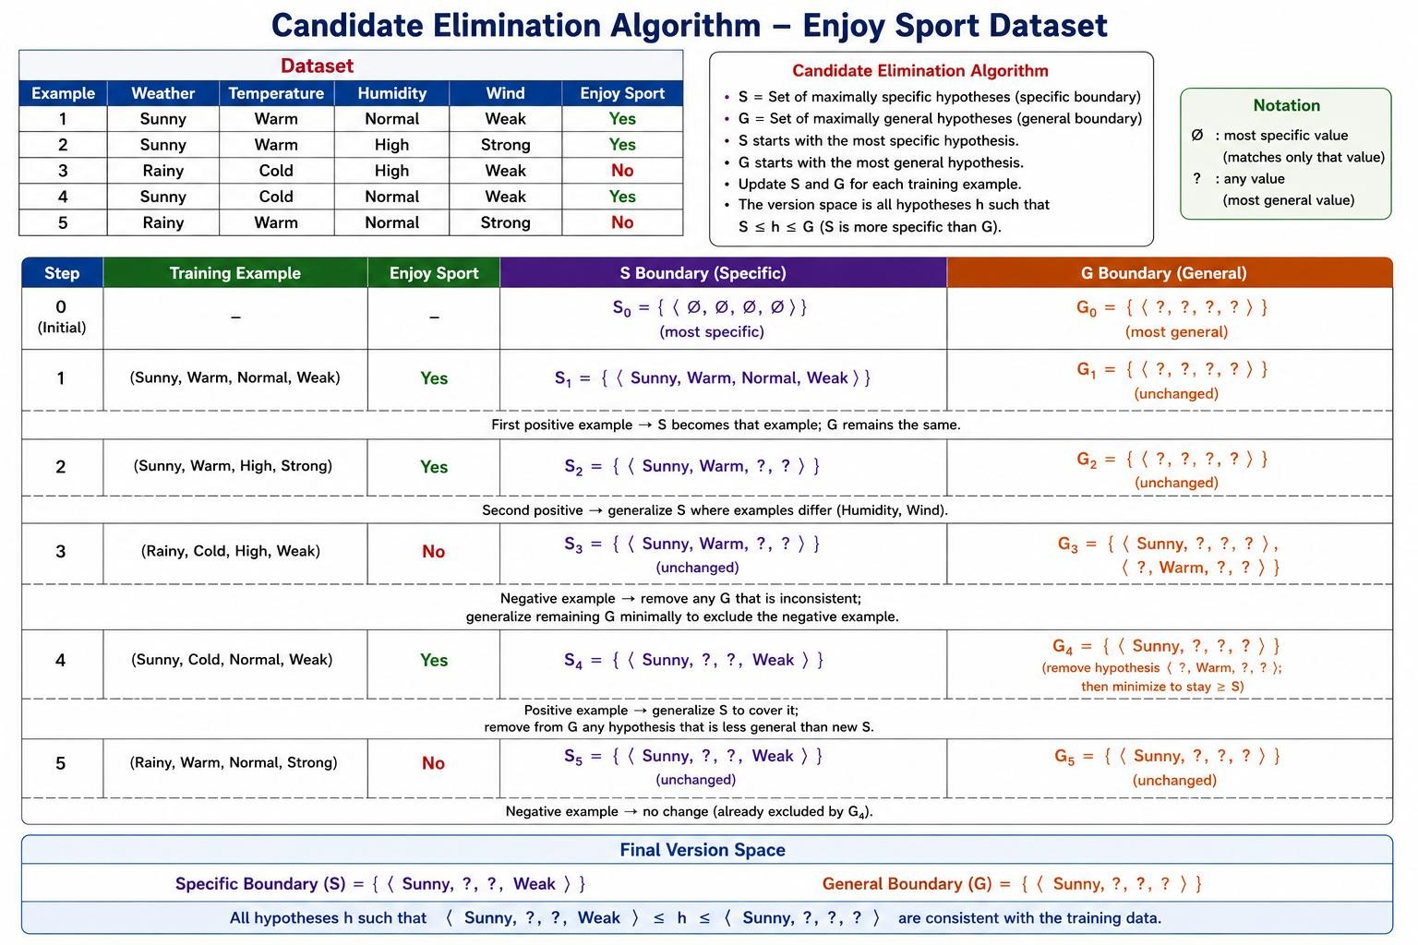

5. In the context of the Find-S algorithm, consider the dataset used to determine whether a customer will buy a product based on attributes such as Age, Income, Student, and Credit Rating. Apply the Find-S algorithm to determine the maximally specific hypothesis. Show step-by-step updates after each positive example and ignore negative examples. Finally, provide the final hypothesis.
(5 Marks)

Dataset:

Example | Age | Income | Student | Credit Rating | Buys Product
1 | Young | High | No | Fair | No
2 | Young | High | No | Excellent | No
3 | Middle | High | No | Fair | Yes
4 | Senior | Medium | No | Fair | Yes

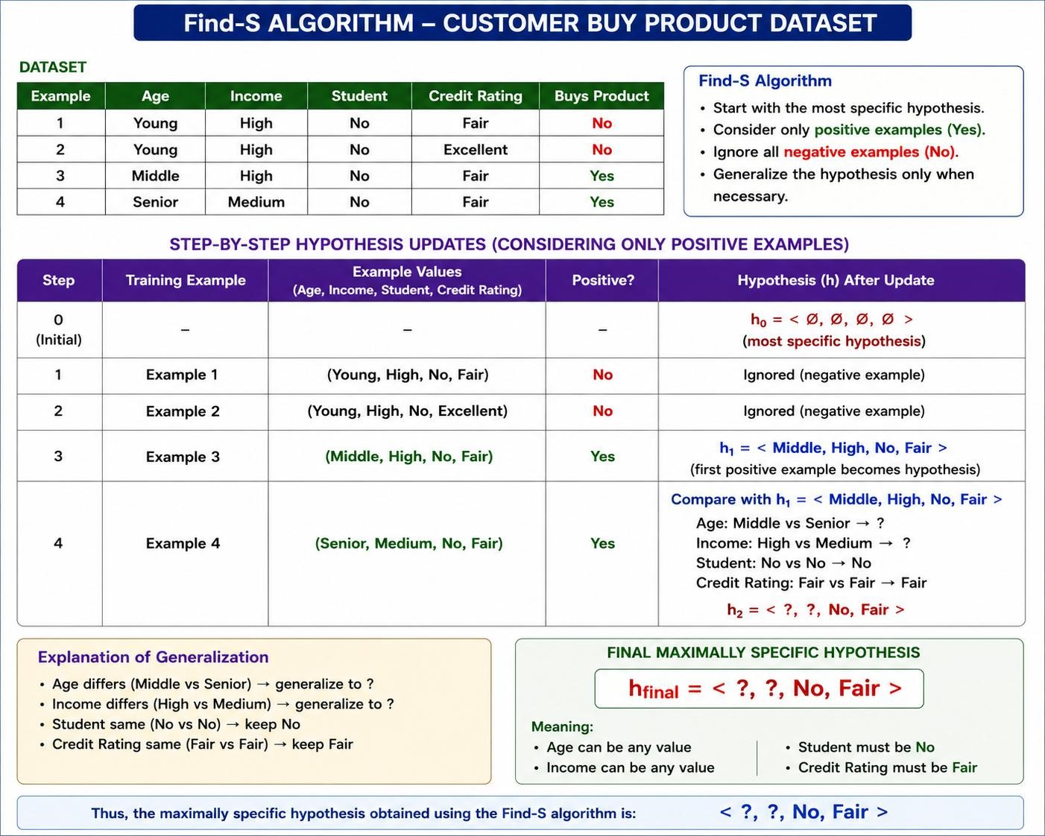

RUBRICS FOR CALCULATION

Criteria | Weightage | Level 4 –  Exemplary (5 Marks) | Level 3 –  Proficient (4 Marks) | Level 2 –  Developing (2–3 Marks) | Level 1 –  Beginning (0–1  Mark)
Conceptual  Understanding | 30 | Demonstrates clear  and complete understanding of the concept | Good  understanding  with minor gaps | Basic understanding with some  misconceptions | Poor or incorrect understanding
Accuracy of  Answer | 20 | Completely correct answer with no  errors | Mostly correct with minor errors | Partially correct with noticeable  errors | Incorrect or irrelevant answer
Application of  Knowledge | 20 | Correctly applies concepts to solve  the  question/problem | Applies concepts  with minor  mistakes | Limited or partially correct application | No or incorrect application
Completeness of Response | 15 | Covers all required parts of the  question | Covers most  parts with minor  omissions | Covers only some  parts | Incomplete or missing response
Clarity &  Presentation | 15 | Clear, concise, and well-organized answer | Understandable with minor issues | Somewhat unclear or poorly structured | Difficult to understand

